Assignment 6 | Lab 6
Operating Systems Lab
Arnav Samal – 122CS0107

Question 1:

Input and add two (mxn) matrices. Main thread creates m child
threads. Thread1 computes the 1st row, Thread2 computes the 2nd row,
..., Threadm computes the mth row elements of the result matrix.

Code:
#include<stdio.h>
#include<pthread.h>
#include<stdlib.h>
#include<unistd.h>
#include<string.h>

#define m 3
#define n 2

int A[m][n], B[m][n], SUM[m][n];
pthread_t thread[m];

void *addition(void *arg) {
int row = (int)arg;
printf("Inside Thread/Row: %d\n", row);
for(int j = 0; j < n; j++) {
SUM[row][j] = A[row][j] + B[row][j];
}
}

int main() {
// Input
for (int i = 0; i < m; i++) {
for (int j = 0; j < n; j++) {
int temp;
printf("For A, enter number at (%d, %d) index: ", i, j);
scanf("%d", &temp);
A[i][j] = temp;
printf("For B, enter number at (%d, %d) index: ", i, j);
scanf("%d", &temp);
B[i][j] = temp;
}
}

// Displaying A
printf("\nMatrix A:\n");
for (int i = 0; i < m; i++) {
for (int j = 0; j < n; j++) {
printf("%d ", A[i][j]);
}
printf("\n");
}

// Displaying B
printf("\nMatrix B:\n");
for (int i = 0; i < m; i++) {
for (int j = 0; j < n; j++) {
printf("%d ", B[i][j]);
}
printf("\n");
}

printf("\n");
// Performing Addition
int row = 0;
// Creating Thread
for (int i = 0; i < m; i++) {
pthread_create(&thread[i], NULL, &addition, (int *)row);
row++;
}
// Waiting for Thread to Finish
for (int i = 0; i < m; i++) {
pthread_join(thread[i], NULL);
}

// Display Addition of mA and mB
printf("\nSum of Matrix A and B:\n");
for (int i = 0; i < m; i++) {
for (int j = 0; j < n; j++) {
printf("%d ", SUM[i][j]);
}
printf("\n");
}
return 0;
}

Output:
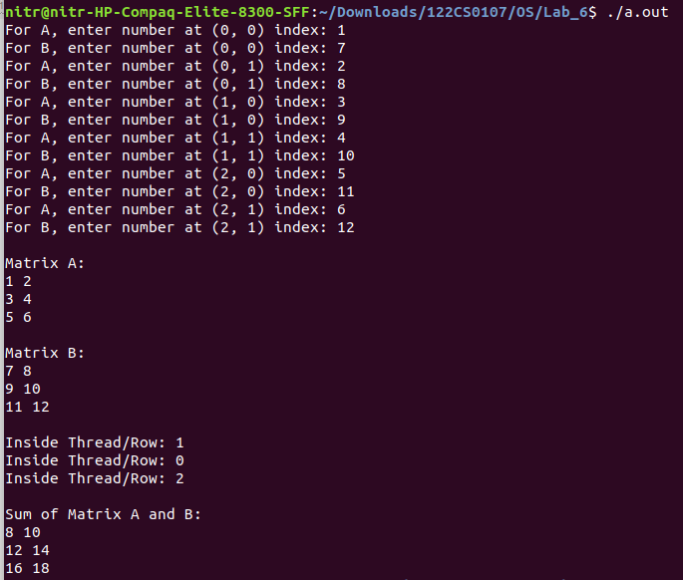

Question 2:

Modify the program to create m*n threads.

Code:

#include <stdio.h>
#include <pthread.h>
#include <stdlib.h>
#include <unistd.h>
#include <string.h>

#define m 3
#define n 2

int A[m][n], B[m][n], SUM[m][n];
pthread_t thread[m][n];

struct arg_struct {
int row;
int column;
};

void *addition(void *args) {
struct arg_struct *index = (struct arg_struct *)args;
int row = index->row;
int column = index->column;

printf("Inside Thread (Row: %d, Column: %d)\n", row, column);
SUM[row][column] = A[row][column] + B[row][column];
free(args);
}

int main() {
// Input
for (int i = 0; i < m; i++) {
for (int j = 0; j < n; j++) {
printf("For A, enter number at (%d, %d) index: ", i, j);
scanf("%d", &A[i][j]);
printf("For B, enter number at (%d, %d) index: ", i, j);
scanf("%d", &B[i][j]);
}
}

// Displaying A
printf("\nMatrix A:\n");
for (int i = 0; i < m; i++) {
for (int j = 0; j < n; j++) {
printf("%d ", A[i][j]);
}
printf("\n");
}

// Displaying B
printf("\nMatrix B:\n");
for (int i = 0; i < m; i++) {
for (int j = 0; j < n; j++) {
printf("%d ", B[i][j]);
}
printf("\n");
}

printf("\n");

// Performing Addition
for (int i = 0; i < m; i++) {
for (int j = 0; j < n; j++) {
struct arg_struct *args = malloc(sizeof(struct arg_struct));
args->row = i;
args->column = j;
pthread_create(&thread[i][j], NULL, &addition, (void *)args);
}
}

// Waiting for Threads to Finish
for (int i = 0; i < m; i++) {
for (int j = 0; j < n; j++) {
pthread_join(thread[i][j], NULL);
}
}

// Display Addition of A and B
printf("\nSum of Matrix A and B:\n");
for (int i = 0; i < m; i++) {
for (int j = 0; j < n; j++) {
printf("%d ", SUM[i][j]);
}
printf("\n");
}
return 0;
}

Output:
